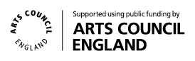

September – November 2017 - Art Exhibitions and Events at Plymouth Arts Centre

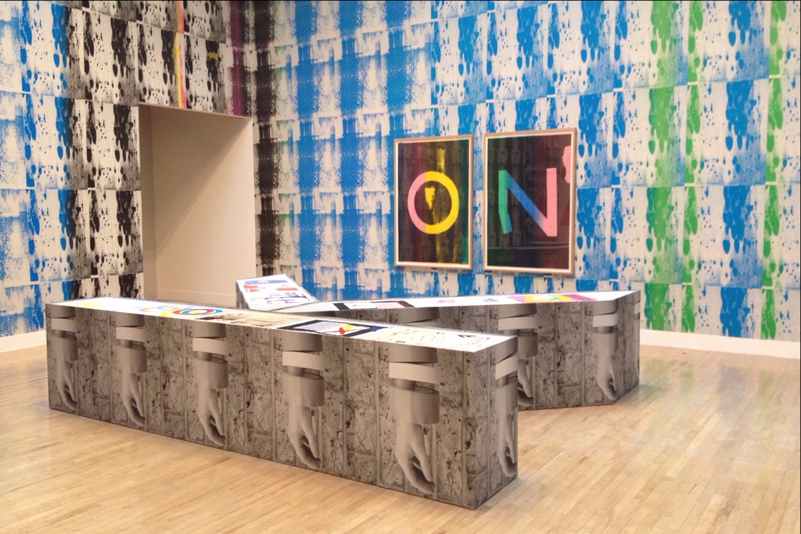
Ciara Phillips, Installation view of Just You, 2014, Bergen Kunsthall. Photo credit: Bergen Kunsthall;

We The People Are The Work
22.09.17–18.11.17

A major visual arts project in Plymouth that will explore ideas of power, protest and the public curated by Simon Morrissey
wethepeoplearethe.work

The project will build connections between the people of Plymouth and six internationally renowned artists through structures that involve people living in Plymouth in generating the ideas and artworks in the exhibition alongside the artists.

Venues across the city ranging from Plymouth City Council’s Council House to the city’s public galleries will be animated by a series of new commissioned artworks that explore our engagement with politics and identity. In the wake of recent global events - from Brexit, to the election of Donald Trump as the new president of the United States, to the recent UK general election - the exhibition explores both the shared experiences and social differences that shape our society and our aspirations and fears for the future.

We The People Are The Work is presented by PVAPG (Plymouth Visual Art Programming Group), a partnership between The Gallery at Plymouth College of Art, KARST, Peninsula Arts at Plymouth University, Plymouth Arts Centre and The Box, Plymouth. It is part of Horizon, a collaborative two year programme of visual contemporary arts, funded through Arts Council England’s Ambition for Excellence fund and led by Plymouth Culture.
For more information about Horizon visit plymouth-horizon.co.uk
More information about the exhibitions at the other venues is below these listings.

Ciara Phillips
PLYMOUTH ARTS CENTRE
Ciara Phillips uses the discipline of printmaking to explore social concerns and develop collaborative practices. Regularly opening up her exhibitions as working print studios, she uses them as places for investigation, social action, discussion and debate.

In Plymouth Phillips has made a major new installation that takes over the multiple galleries and social spaces of Plymouth Arts Centre to turn them into a production space exploring the intersection of the personal and the political where she will work live in the exhibition with groups of women from the city to produce printed textiles to represent their voices and concerns.

Plymouth Arts Centre is a nationally acclaimed centre for contemporary art, independent cinema and creative learning. It commissions work by national and international artists, working with them to develop a challenging and varied exhibitions complimented by our dynamic independent cinema programme.

Breakfast Panel Discussion
Sunday 24 Sept, 10:00–11:30
Plymouth Arts Centre
Free, no need to book
Ben Borthwick, Artistic Director at Plymouth Arts Centre, sits down with some of the artists in the show for an informal conversation about their experience of commissioning processes and We The People Are The Work.

Creative Play
Tuesdays 26 Sept, 10 Oct, 24 Oct, 7 Nov, 11:00–12:30
Plymouth Arts Centre
Recommended for children aged 2–5 and their adults
£5 includes a hot drink and squash
Booking via Plymouth Arts Centre Box Office 01752 206114
These open-ended activities will introduce you to new ideas, materials and creative processes which you can try again at home.

Bringing in Baby Gallery Tour
Tuesday 3 Oct, 11:00–12:30
Plymouth Arts Centre
Adults and under 1s. £2 includes a hot drink
Booking via Plymouth Arts Centre Box Office 01752 206114
Drop in for a guided tour of our exhibition with PAC’s visual arts team and your little ones.

Family letterpress workshop with Kiss & Bite Press
Saturday 28 Oct, 13.30–16.00
Plymouth Arts Centre
£5 per family, via Plymouth Arts Centre Box Office 01752 206114
Join Kiss & Bite Press for this unique workshop making your own letterpress statements and political postcards. Kiss & Bite Press is run by Plymouth-based typographer & former newspaper editor Alan Qualtrough.

PAC Home Talk: Morgan Quaintance
Tuesday 3 Oct, 18:00
Plymouth Arts Centre
£3/free PAC Home members, via Plymouth Arts Centre Box Office 01752 206114
Writer, curator, musician and Culture Show presenter, Morgan speaks about contemporary art and politics.

Alan Qualtrough
Wednesday 15 Nov, 13:00–13:40
Plymouth Arts Centre
Designer and former newspaper editor, Alan discusses the changing landscape for print media and engaging young people with his ‘Stand Up & Be Printed’ project.

Cinema screenings

We Are Many
Thursday 28 Sept, 18:00
Plymouth Arts Centre
Standard ticket pricing via Plymouth Arts Centre Box Office 01752 206114
Dir. Amir Amirani, UK, 2014, 104 mins, Cert: 12
A British documentary about the 2003 anti-war protests across 800 cities, estimated to involve up to 30 million people.

The Way We Live
Friday 6 Oct, 17:30
The Council Chamber, The Council House
£7.50, via Plymouth Arts Centre Box Office 01752 206114
Dir. Jill Craigie, UK, 1946, 64 mins, Cert: U
A much loved post-war film showing the conception of the Watson-Abercrombie plan for Plymouth’s rebuild in the 1940s.
I Am Not Your Negro
Monday 16 Oct, 19:00
Jill Craigie Cinema, Plymouth University
Standard ticket pricing, via Peninsula Arts Box Office 01752 585050
Dir. Raoul Peck, USA/France, 2016, 93 mins, Cert: 12A
Cast: Samuel L Jackson
A challenging documentary connecting the Civil Rights movement to the present #BlackLivesMatter movement.

The Jarman Award
Wednesday 25 Oct, 17:30
Plymouth Arts Centre
£3/free PAC Home members, booking via Plymouth Arts Centre Box Office 01752 206114
Screening of moving image work by this year’s shortlisted artists: Lawrence Abu Hamdan, Oreet Ashery, Adham Faramawy, Melanie Manchot, Charlotte Prodger and Marianna Simnett. This event will include a Q&A with one of the artists (see WTPATW website for confirmed guest).

Citizen Jane: Battle for the City
Friday 27 Oct, 17:30
The Council Chamber, The Council House
£7.50, via Plymouth Arts Centre Box Office 01752 206114.
Dir. Matt Tyrnauer, USA, 2016, 92 mins, Cert: PG
This inspiring documentary plots the story of activist Jane Jacobs’ fight against the redevelopment of New York City in the 1960s; an interesting take on the conflict between idealism and capitalism.

Everyday Rebellion
Thursday 2 Nov, 18:00
Plymouth Arts Centre
Standard ticket pricing via Plymouth Arts Centre Box Office 01752 206114
Dir. Arash T. Riahi & Arman T. Riahi, Austria/Swiss (subt.), 2013, 110 mins, Cert: 12
A truly international documentary exploring creative and peaceful protests across the globe from the Occupy movement to the Arab Spring.

Remembrance
Monday 6 Nov, 19:00
Jill Craigie Cinema, Plymouth University
Standard ticket pricing, via Peninsula Arts Box Office 01752 585050
Dir. Colin Gregg, UK, 1982, 117 mins, Cert: PG
Cast: Gary Oldman, Timothy Spall, John Altman, David John
Were you an extra in Remembrance? Join us for a reunion screening of this film shot in and around Plymouth in the early ‘80s and not shown publicly since aired on Channel 4 in their first year of broadcast. Remembrance will be introduced by Writer Hugh Stoddart and Director Colin Gregg.

Battleship Potemkin with The Imperfect Orchestra
Saturday 11 Nov, 19:00
Theatre 1, Plymouth University
Standard ticket pricing, via Peninsula Arts Box Office 01752 585050.
Dir. S.M. Eisenstein, Soviet Union, 1925, 66 mins, Cert: PG
Local musicians, the Imperfect Orchestra present a new score to accompany Eisenstein’s silent film masterpiece.

Antonio Vega Macotela & Eduardo Thomas
PENINSULA ARTS, PLYMOUTH UNIVERSITY

Antonio Vega Macotela and Eduardo Thomas’ multidisciplinary practices often engage particular communities such as prison inmates, soldiers or miners and draw on the history of experimental film and documentary strategies respectively.

In their new commission the Mexican artists team up to explore notions of representation, identity, visibility, through working with local residents who took part as extras in Tim Burton’s 2010 version of Alice in Wonderland, parts of which were shot in Plymouth.

Peninsula Arts at Plymouth University hosts the largest contemporary art gallery in Plymouth and delivers a significant programme at the cutting-edge of global contemporary art including exhibitions, film, theatre, dance, music and talks.

Matt Stokes
THE GALLERY AT PLYMOUTH COLLEGE OF ART

Matt Stokes’ works begin with an immersive research process that explores the social structures of the place he is working in, resulting in the production of films, installations and events. These outcomes hold collaboration at the centre of both their formation and philosophy, often being made directly with people from the collectives they are celebrating.

In his new commission Stokes has worked with different generations of the punk-DIY music scene in Plymouth to create a multi-screen film work that poignantly explores punk’s legacy of protest and resistance, whilst charting the decline of live music venues in the city.

The Gallery at Plymouth College of Art specialises in supporting artists at various stages of their careers, enabling them to produce new exhibitions, and offering exciting opportunities to enhance artists’ professional practice in fresh and interesting ways.

Peter Liversidge
THE COUNCIL HOUSE

No single category or definition can successfully describe Peter Liversidge’s diverse practice, which includes work in almost every conceivable medium. The subjects of Liversidge’s work can be equally diverse, but they are all united by an underlying streak of dark, absurdist humour and a persistent questioning of the world around us.

Liversidge has made a series of new works for Plymouth that bring together the ideas and voices of diverse individuals from all walks of life in the city to be made into placards at The Council House. These signs will be spread around the city by the public and through events, including a ritual burning in the bonfire on The Hoe on 5th November led by Plymouth school children. Liversidge’s work at the Council House will also be accompanied by a new temporary public art work for the flagpoles on the Hoe throughout October & November.

The Council House is a key example of late-1950s British Modernism located in the heart of Plymouth's city centre and a permanent reminder of the ambitious scheme to rebuild and regenerate the city after the devastation of the Blitz during the Second World War. Until 2019 the ground floor is the location for a series of temporary exhibitions co-ordinated by the City Museum and Art Gallery while its main building is closed for the construction of The Box.

Claire Fontaine
KARST

Claire Fontaine is the name of a collective feminist artist, lifted from a popular brand of French stationary. Working in neon, video, sculpture and text, Fontaine’s work often interrogates through her art the impotence of people in the face of social and political issues.
For We The People Are The Work Fontaine has produced a series of new works that tackle the questions of morality, agency and freedom of speech through illuminated text in the space. Lifting quotes from Donald Trump and the Brexit debate, she creates a visual and conceptual polyphony where the viewer is invited to take a position.
KARST is Plymouth’s largest independent contemporary art venue, comprising a free public gallery and artists’ studios in the industrial Millbay area of Plymouth. KARST are at the forefront of the growing South West art scene, hosting critically acclaimed artists from around the world as well supporting the city’s own artistic talent.

Project Hub
We recommended starting your visit to We The People Are The Work at Peninsula Arts in Plymouth University. Here you will find the project hub which introduces you to the project through documentary films, archive material and information that charts the artists’ work being made for Plymouth. You will also be able to explore additional resources to help you navigate the show and find out more information about the extensive events programme.
School Visits
Want to bring a large group to see the exhibition? Let us know by emailing museumvisits@plymouth.gov.uk and we’ll help you plan your visit.

To download a free activity and resource pack for schools please visit wethepeoplearethe.work/learning

Exhibition Launch
Friday 22 Sept, 17:00–22:00
Starts at Peninsula Arts and will progress to the other venues on foot, finishing at KARST.
Free, RSVP to contact@wethepeoplearethe.work

Join us at Peninsula Arts for the official launch of We The People Are The Work at 17:30 and enjoy an introduction to the artists’ work at the five venues across the City.
17:00–19:00 Peninsula Arts & The Gallery at Plymouth College of Art
18:00–20:30 Plymouth Arts Centre & The Council House
20:00–22:00 KARST

Curator’s Tour
Saturday 23 Sept, 11:00–14:00
Starts at Peninsula Arts and will progress to the other venues on foot, finishing at KARST.
Free, Booking via Peninsula Arts Box Office 01752 585050.

Join We The People Are The Work curator Simon Morrissey on a walking tour of the five venues. Throughout the tour Simon will discuss the ideas behind the exhibition and how the participatory process of the project has influenced the development of each of the works presented in the galleries.

